覃星源附件1：加布拉植物群化石类群及其现生最近亲缘种形态对比图

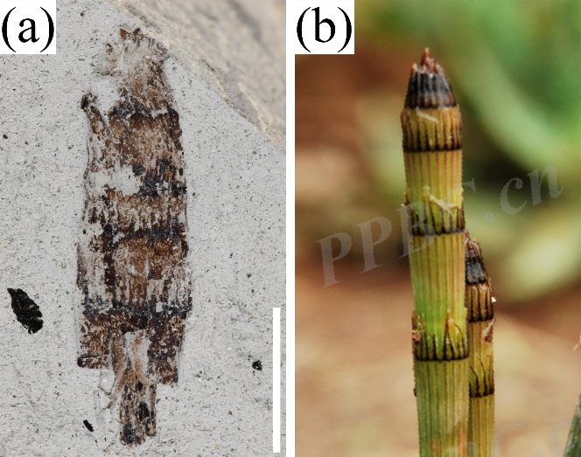
(a)木贼(近似种)Equisetum cf. hyemale (比例尺=5 mm)；(b)木贼E. hyemale (@宋鼎PPBC.cn/359464)
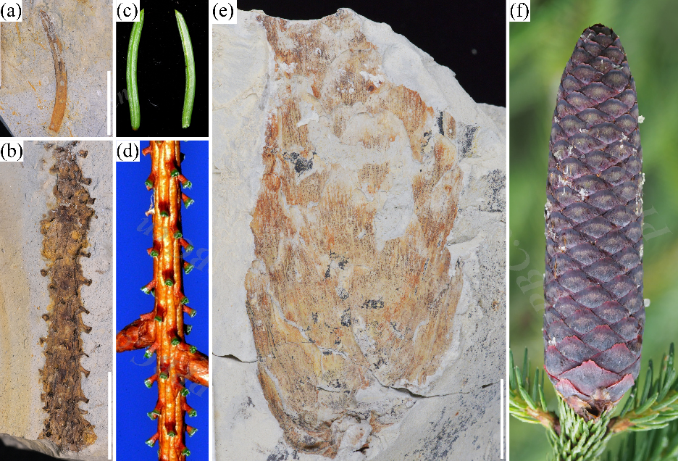
(a)、(b)、(c)云杉属(未定种)Picea sp. (比例尺=10 mm)；(c)云杉P. asperata (@潘建斌PPBC.cn/12823931)；(d)云杉P. asperata (@徐永福PPBC.cn/4137778)；(f)西藏云杉P. spinulosa (@林秦文PPBC.cn/8074602)
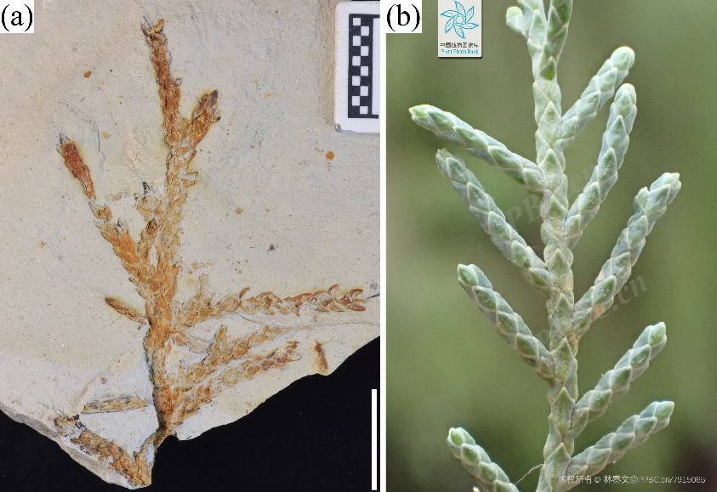
(a)柏木属(未定种)Cupressus sp. (比例尺=10 mm)；(b)西藏柏木C. torulosa (@林秦文PPBC.cn/7915065)
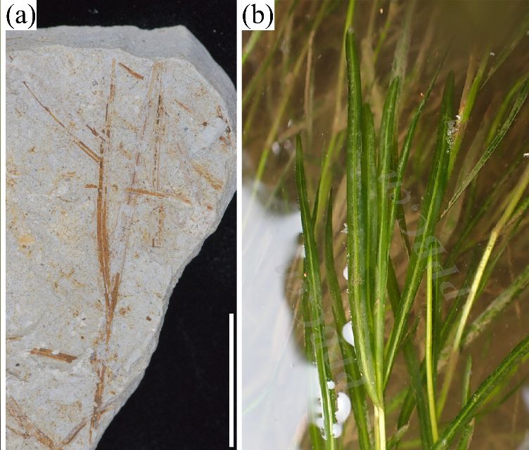
(a)小眼子菜(近似种)Potamogeton cf. pusillus (比例尺=10 mm)；(b)小眼子菜P. pusillus (@刘焱PPBC.cn/10745545)
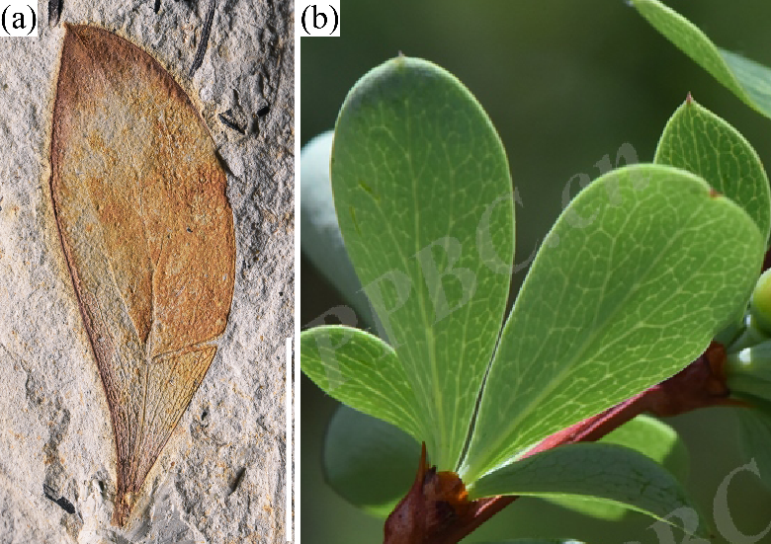
(a)小檗属(未定种)Berberis sp. (比例尺=10 mm)；(b)刺红珠 B. dictyophylla (@汤睿PPBC.cn/6592971)
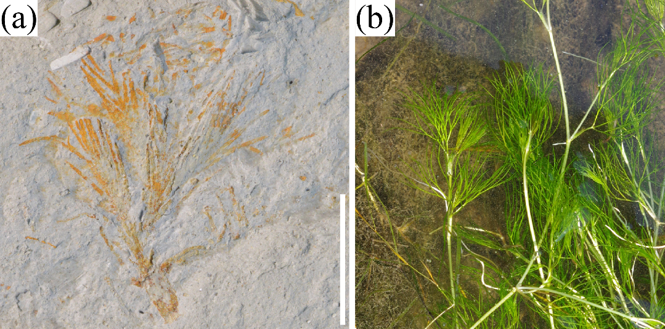
(a)毛柄水毛茛(近似种)Batrachium cf. trichophyllum (比例尺=5 mm)；(b)毛柄水毛茛Batrachium trichophyllum (inaturalist-open-data.s3.amazonaws.com/photos/240771411/original.jpeg)
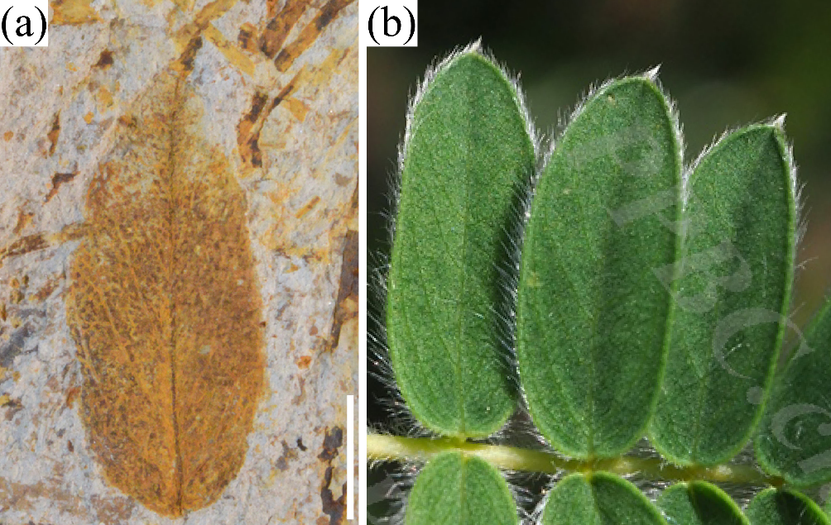
(a)鬼箭锦鸡儿(近似种)Caragana cf. jubata (比例尺=2 mm)；(b)鬼箭锦鸡儿C. jubata (@刘冰PPBC.cn/13104475)
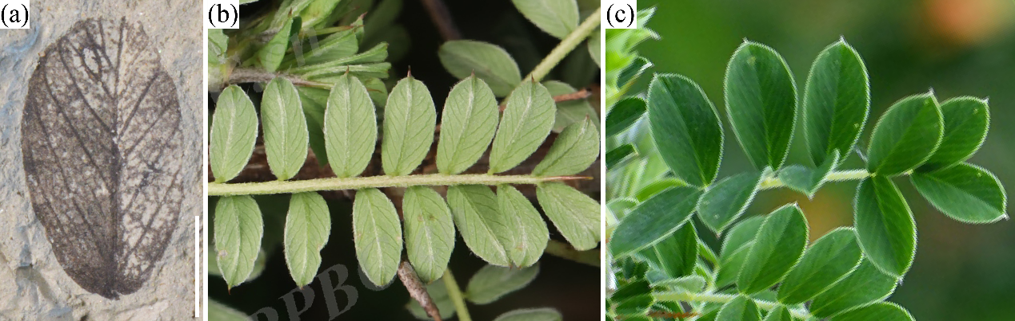
(a)锦鸡儿属(未定种)Caragana sp. (比例尺=2 mm)；(b)二色锦鸡儿C. bicolor (@翦翳翎PPBC.cn/14594405)；(c) 粗刺锦鸡儿C. crassispina (@魏泽PPBC.cn/5299905)
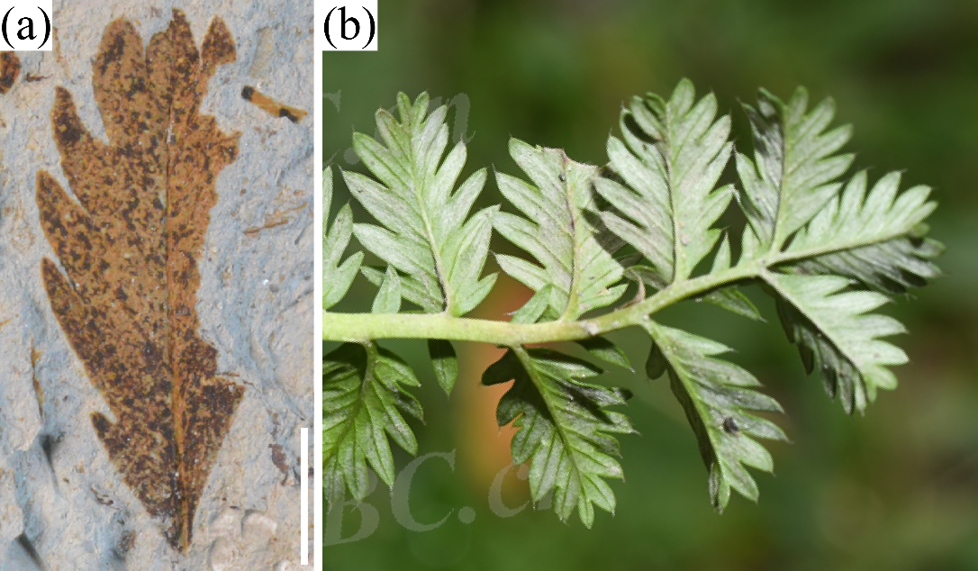
(a)蕨麻(近似种)Argentina cf. anserina (比例尺=2 mm)；(b)蕨麻A. anserina (@李蒙PPBC.cn/15956445)
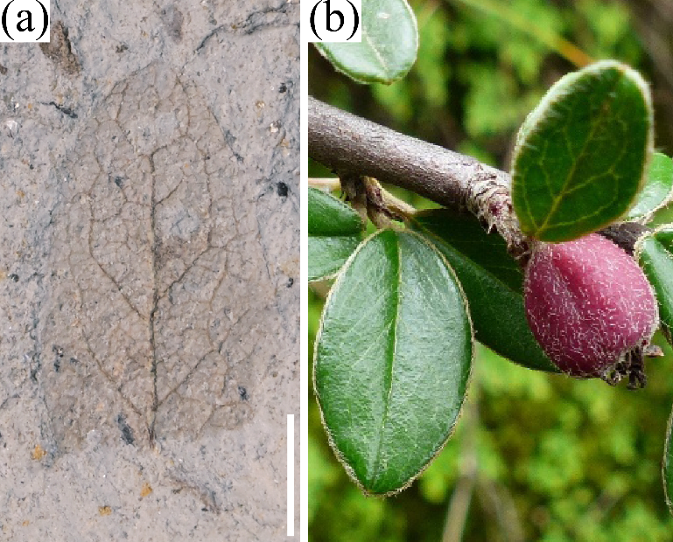
(a)小叶栒子(近似种)Cotoneaster cf. microphyllus (比例尺=2 mm)；(b)细叶小叶栒子C. microphyllus var. thymifolius (efloraofindia.com/wp-content/uploads/2020/10/Cotoneaster%20microphyllus-fruit.JPG)
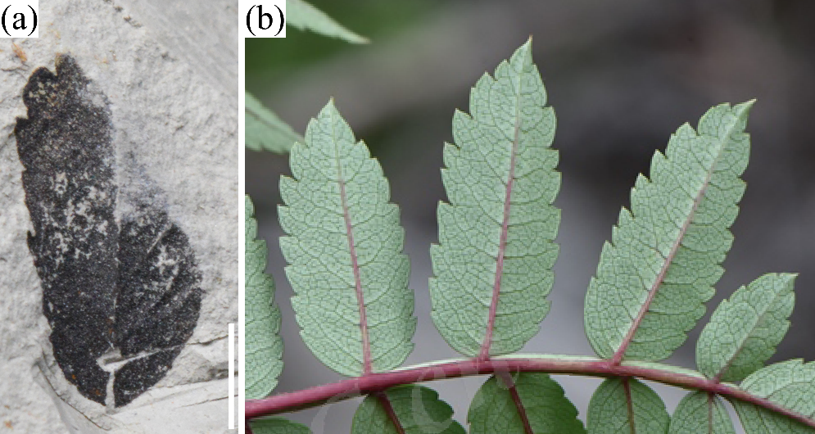
(a)川滇花楸(近似种)Sorbus cf. vilmorinii (比例尺=2 mm)；(b)川滇花楸S. vilmorinii (@汤睿PPBC.cn/6706416)
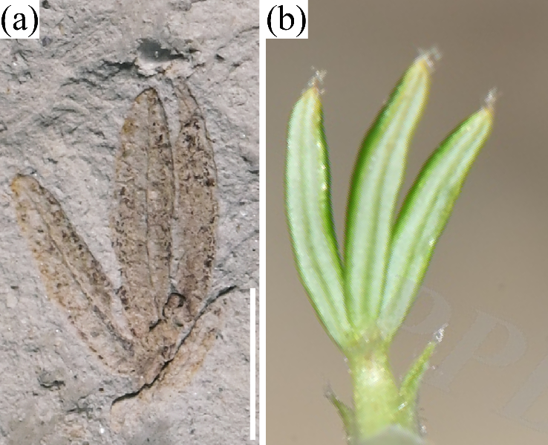
(a)关节委陵菜(近似种)Potentilla cf. articulatum (比例尺=2 mm)；(b)关节委陵菜P. articulatum (@汤睿PPBC.cn/5280390)
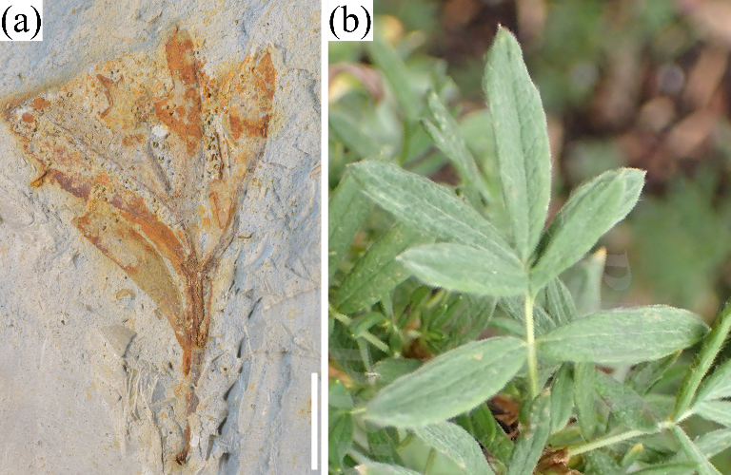
(a)小叶金露梅(近似种)Dasiphora cf. parvifolia (比例尺=5 mm)；(b)小叶金露梅D. parvifolia (@李薇PPBC.cn/16010279)
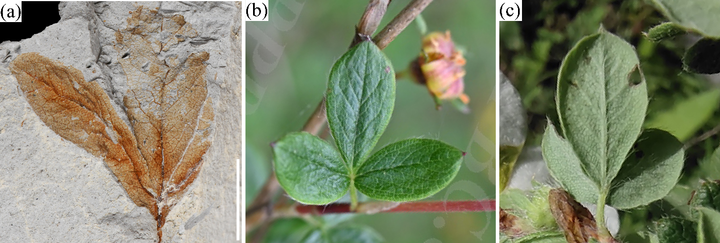
(a)金露梅属(未定种)Dasiphora sp. (比例尺=5 mm)；(b)金露梅D. fruticose (@岑华飞PPBC.cn/12173281)；(c)银露梅D. glabra (@许京新PPBC.cn/14850080)
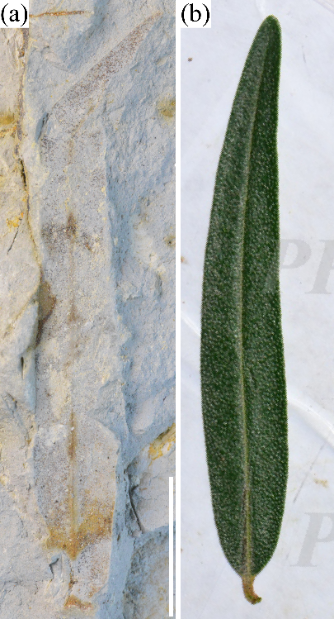
(a)沙棘(近似种)Hippophae cf. rhamnoides (比例尺=10 mm)；(b)中国沙棘H. rhamnoides subsp. Sinensis (@朱仁斌PPBC.cn/5923394)
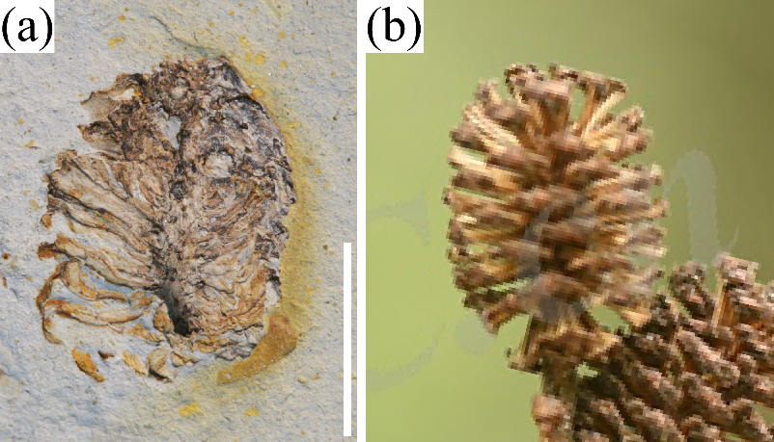
(a)桤木属(未定种)Alnus sp. (比例尺=10 mm)；(b)尼泊尔桤木A. nepalensis (@李蒙PPBC.cn/15901490)
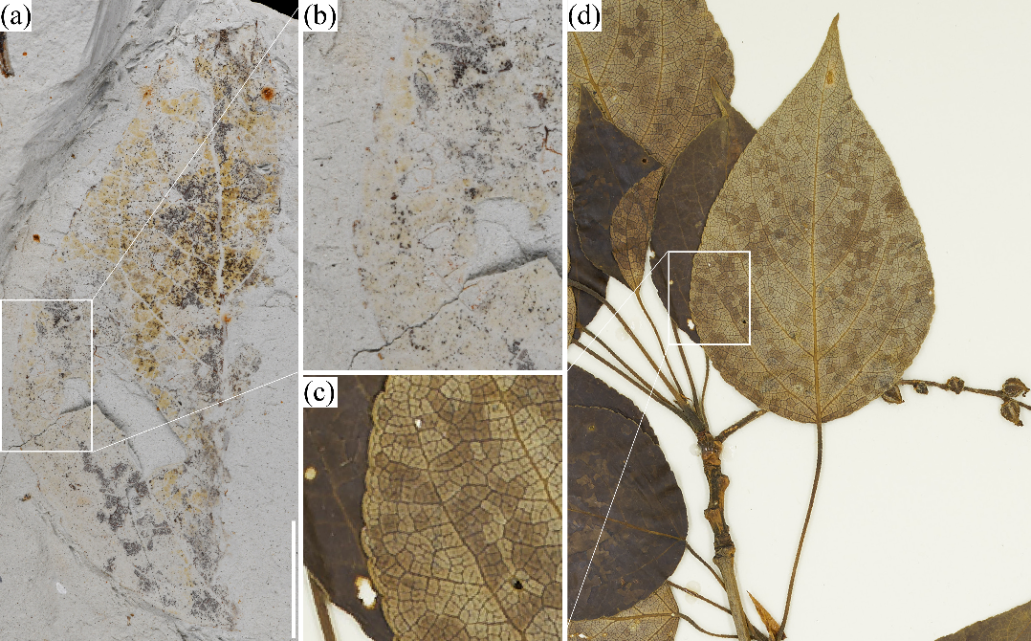
(a)杨属(未定种)Populus sp. (比例尺=10 mm)；(b)康定杨P. kangdingensis (http://ipt.nature.ca/multimedia/431/604/CAN10169908_2023-11-07.jpg)
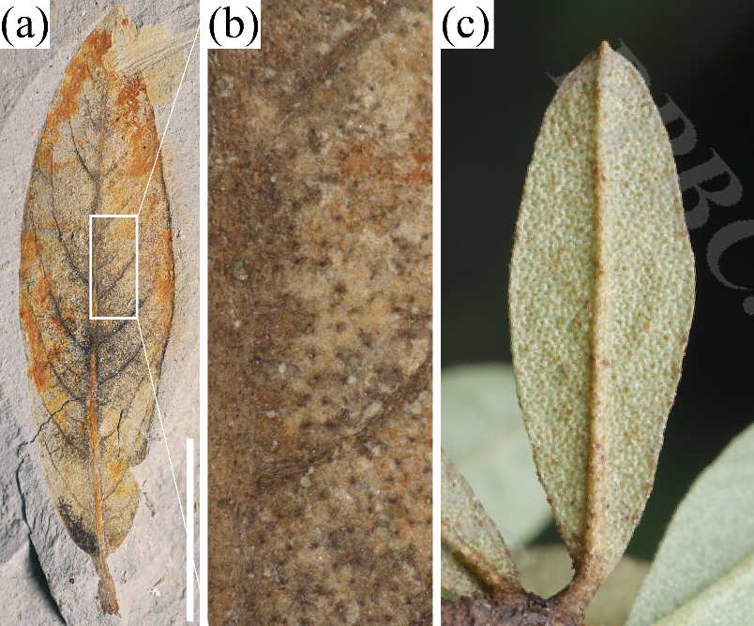
(a)杜鹃花属(未定种)Rhododendron sp. (比例尺=10 mm)；(b)鳞腺杜鹃R. lepidotum (@翦翳翎PPBC.cn/19276022)
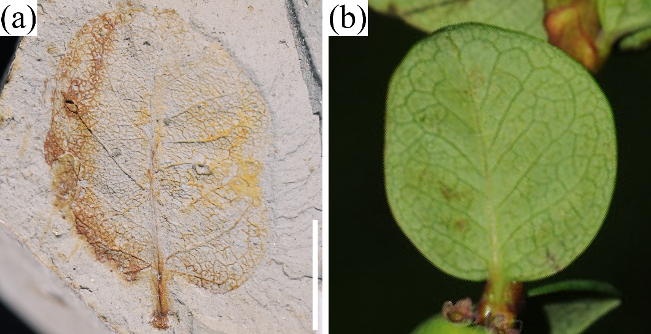
(a)越橘叶忍冬(近似种)Lonicera cf. angustifolia var. myrtillus (比例尺=10 mm)；(b)越橘叶忍冬(近似种)L. angustifolia var. myrtillus (image.cubg.cn/upload/m_photos/midthumb/20210824/3E849x64497863V28625W843J930d948g.jpg)

